www.tdi.texas.gov

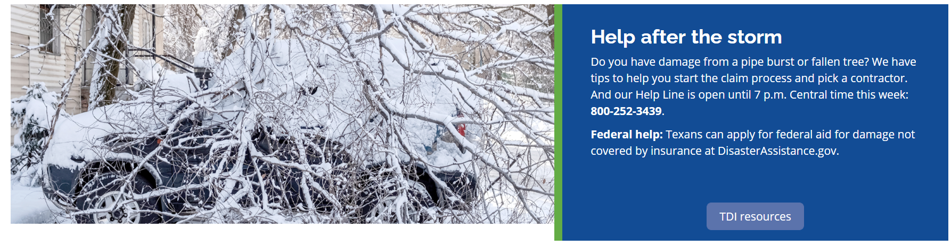

After the storm videos and information:
- FAQ: Winter storms
- Insurance tips following winter storms
- Help for renters with winter storm damage
- Avoiding contractor scams (video)
- Preventing fraud after a storm: a toolkit for city and county officials
Printable information and videos:
- Filing an insurance claim (pdf)
- Working with an adjuster
- Deductibles and contractors
- Water and mold
- Roof replacement
- Insurance not paying enough
Need help with an insurance question?
Call our Help Line at 1-800-252-3439. Monday through Friday, 8 a.m. to 5 p.m. Central time.

